Critical Bug 1:

When the user is on a car make page, the Buggy Rating home button does not take the user back to the home page.

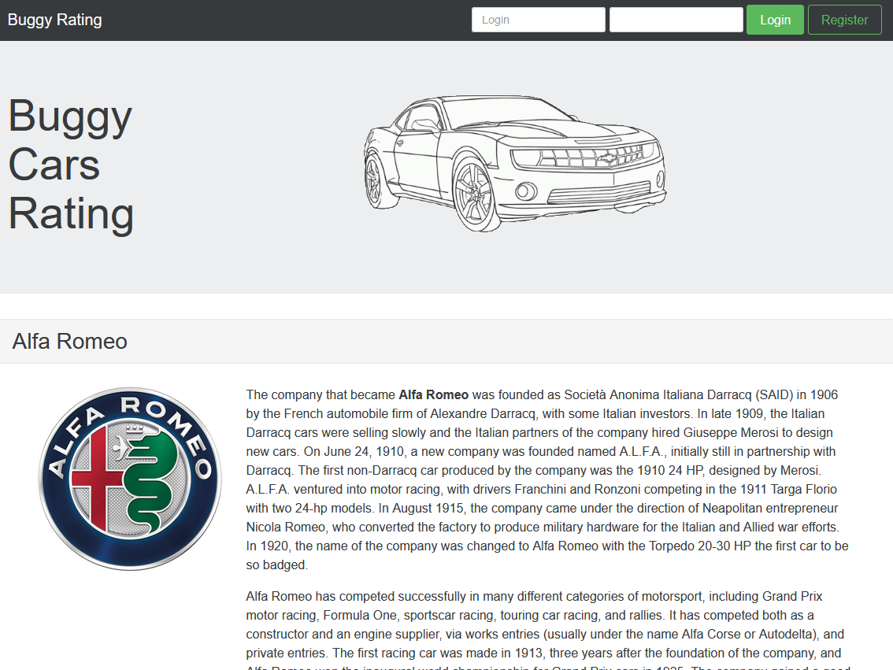



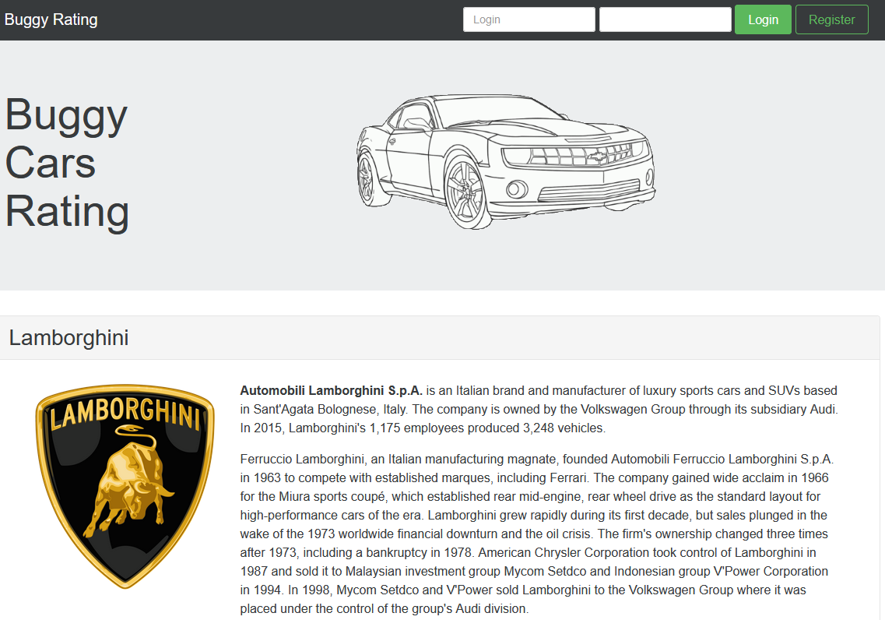



Critical Bug 2:

When the user goes to register with an invalid password, the error message is hard to understand and tells the user a different password criteria each time rather than telling the user the password criteria all at once so they can make a valid password. As per the images below it took me 5 tries to create a valid password as I was not aware of the criteria earlier.

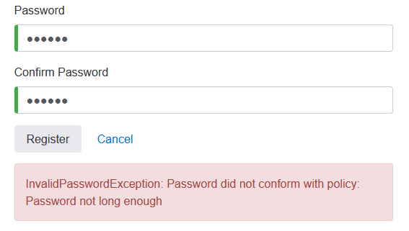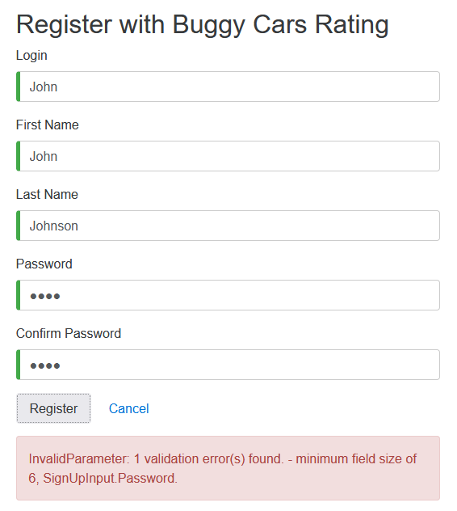

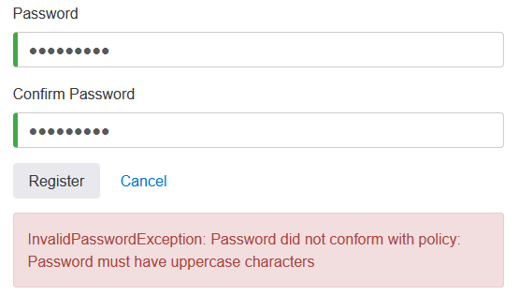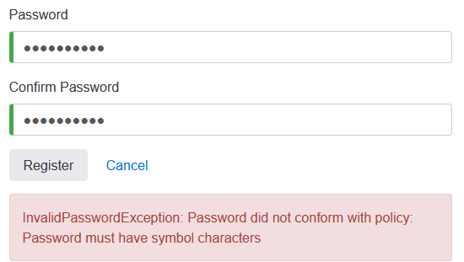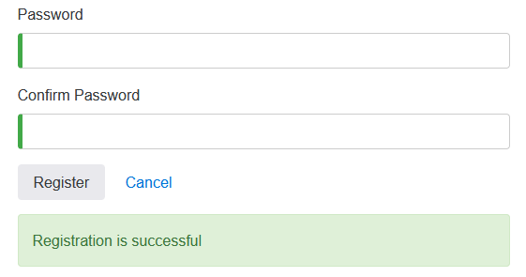

Critical Bug 3:

Links not working. There are multiple links on this website that do not work and just show an infinite loading icon.

1. Popular model on home page is broken
2. In overall rating page none of the model links work and ‘view more’ for comments does not work

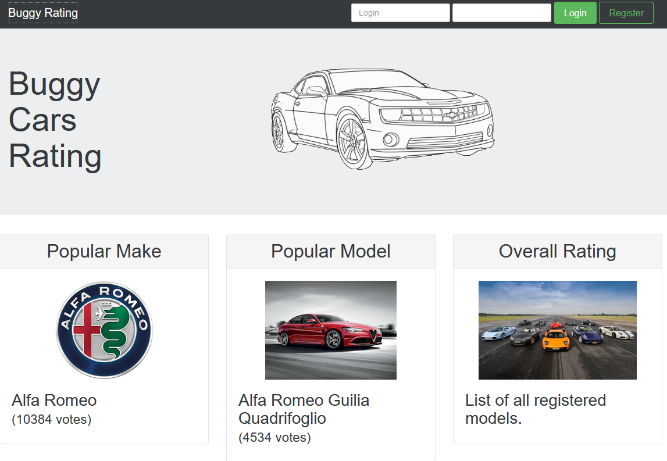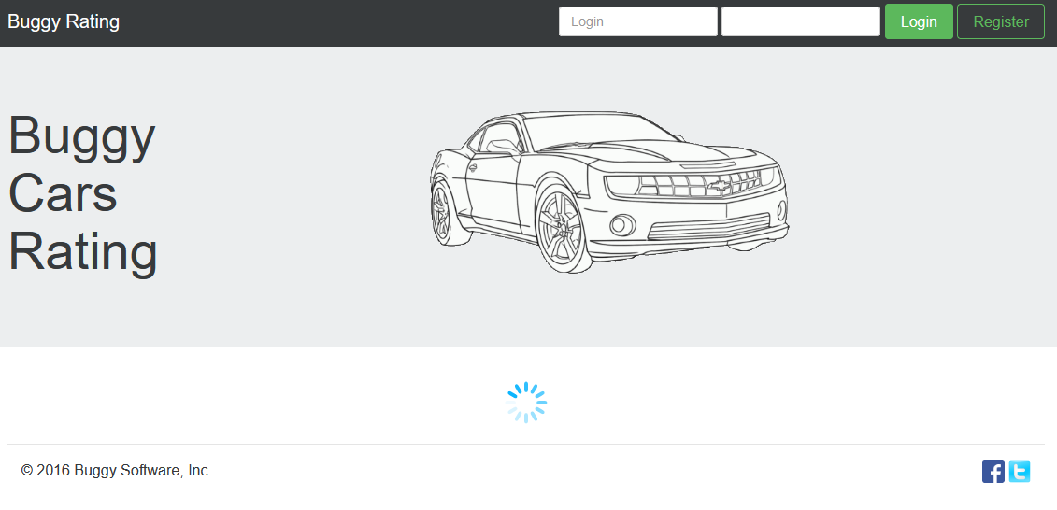

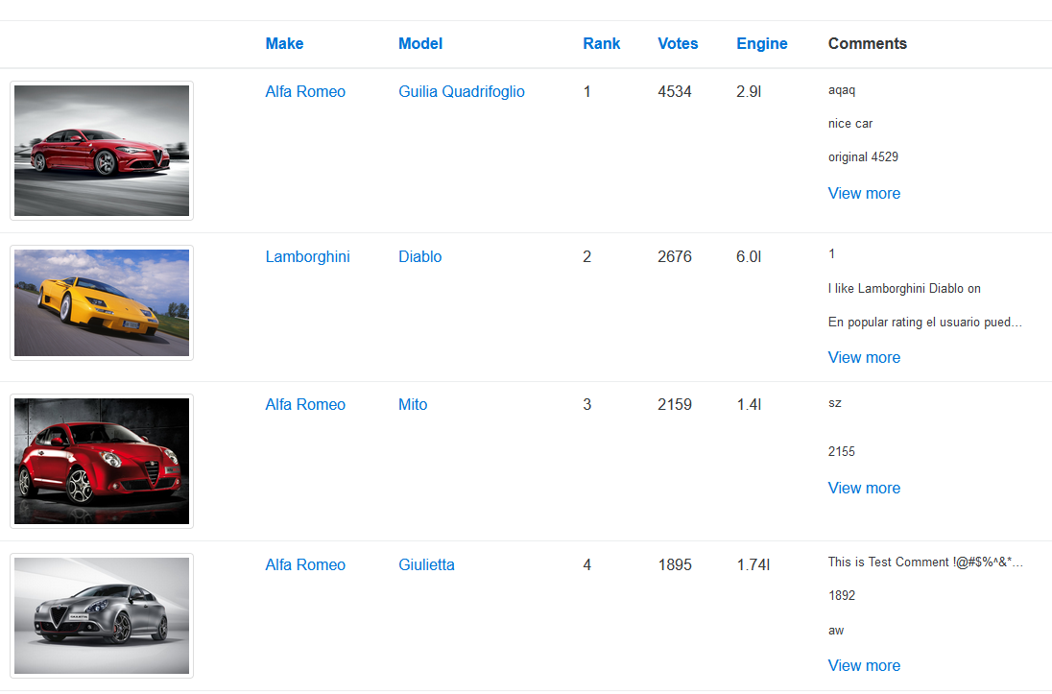

Critical Bug 4:

When sorting via rank on the overall rating page, the rank sorts incorrectly. It sorts to 1, 10, 11, 12 etc instead of 1, 2 ,3 etc. 

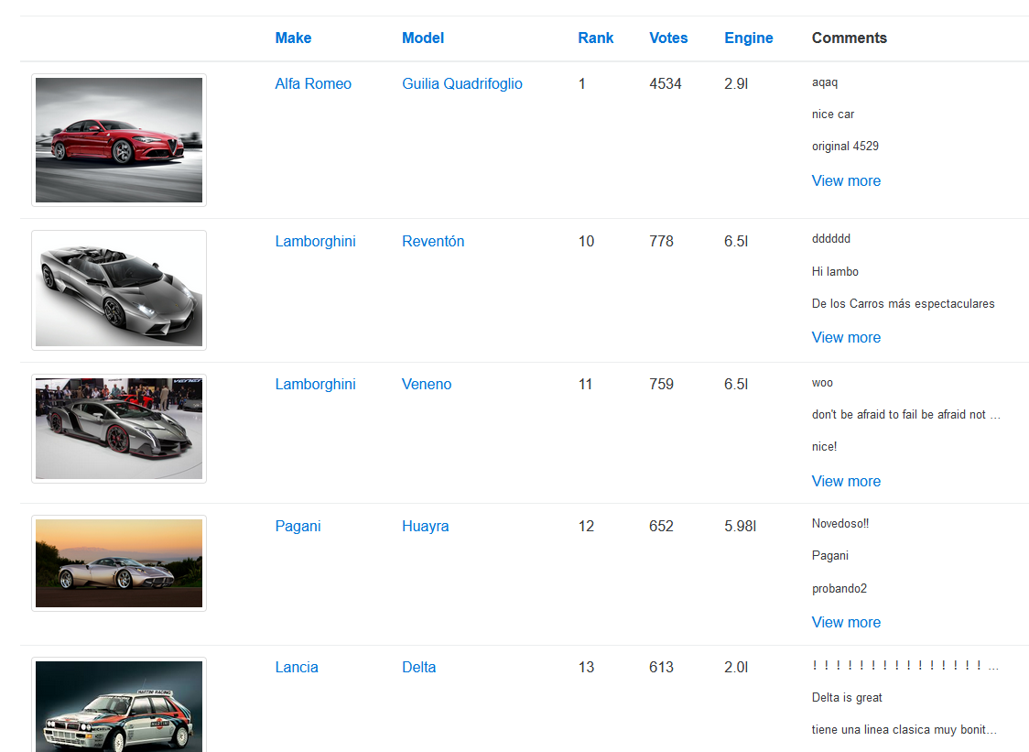

Critical Bug 5:

When navigated to the next set of cars on the overall rating page, the page count goes past the max past count.

